Instructions for Completion of ePERs
- Is this for an employee who has already left the university or an employee who is leaving prior to the issuance of an online ePER certification? If the first option, please see Section 2, if the latter, please see Section 3.

- If an employee has already left the university, which is common with graduating students, certification must be completed by someone with firsthand knowledge of the employee’s effort. This should be the employee’s supervisor, who has access to the terminated employee’s ePER through the UCCS portal and should certify electronically in lieu of completing a hard copy of the employee’s ePER.
  - A hard copy would be provided by the Sponsored Projects Accounting contact, which is a PDF version of the online ePER. It is much quicker to certify online if possible however.
  - If this is not possible, the principal investigator for the sponsored project(s) on which the employee worked may certify a hard copy of the terminated employee’s ePER.
  - When filling out a hard copy of the ePER, enter the appropriate effort percentages on the paper copy in pen.
  - Sign below the statement that says “I certify that the above estimate of effort expended is accurate and covers all work performed during the stated period”.
  - Scan this form and email SPA contact the filled out PDF
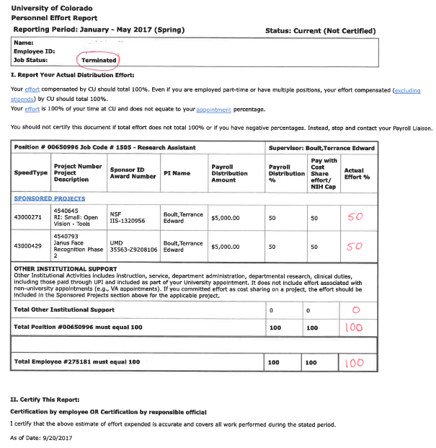

- If an employee is leaving prior to the issuance of the system generated ePER a Letter of Certification for ePERs Memorandum form will need to be filled out and returned to the Sponsored Projects Accounting Office.
  - This form is available on the UCCS Controller’s Office website under the Sponsored Projects Accounting tab.
  - Enter the semester that the employee will be leaving during, for example, if they are leaving the campus on March 20th, then the Spring semester would be appropriate.
  - If there are certain aspects of the project being worked on that are unknown or unclear, for example, the Sponsor Award #, contact the project PI or the Sponsored Projects Accounting office.
  - When filling out the Actual Effort %, Other Institutional Efforts %, and Total Effort, if these percentages are unknown, the HR contact for the department should be able to find this funding distribution. If they cannot, contact the Sponsored Projects Accounting Office for assistance.
    - If an employee works 40 hours a week and devotes 10 hours a week to working on a project and the other 30 hours are devoted to other duties like lecturing, their Actual Effort would be 10/40 = 25% and your Other Institutional Efforts would be 30/40 = 75%. This is to provide an idea of how the percentages are calculated but HR or SPA should still be contacted to verify.
  - Sign and date this form.
  - Scan this form and email SPA contact the filled out PDF

