AUTO FILTER:

Auto filter gives you drop-downs for all column headings:

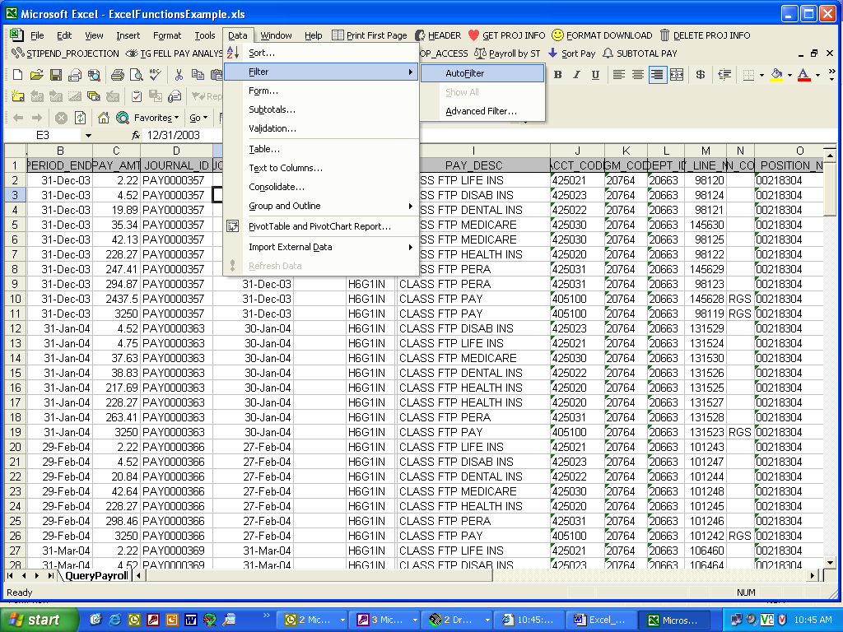

You can then choose a single selection to view (See next 2 images):

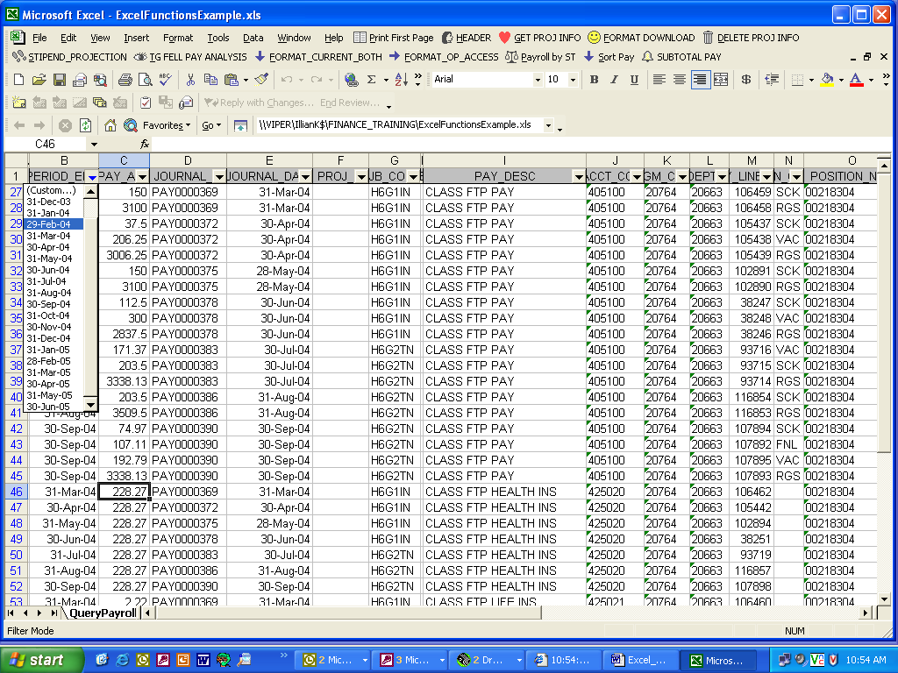

This example has filtered down to all entries with a Pay Period End Date of 29-FEB-04:

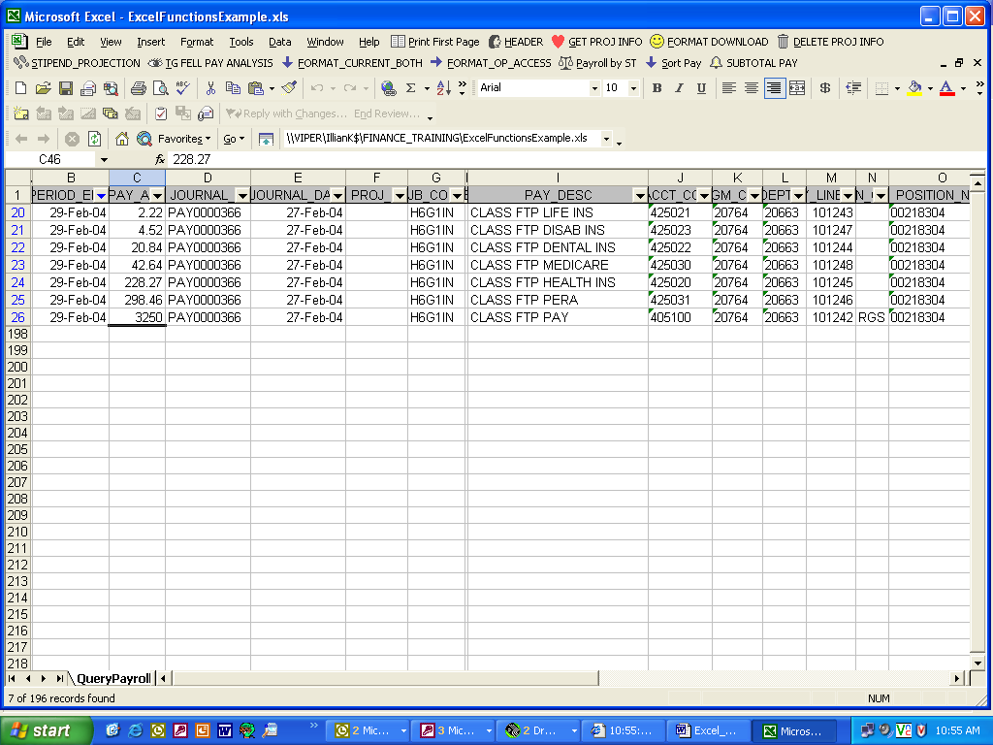

You can also customize the filter: see next 2 images:

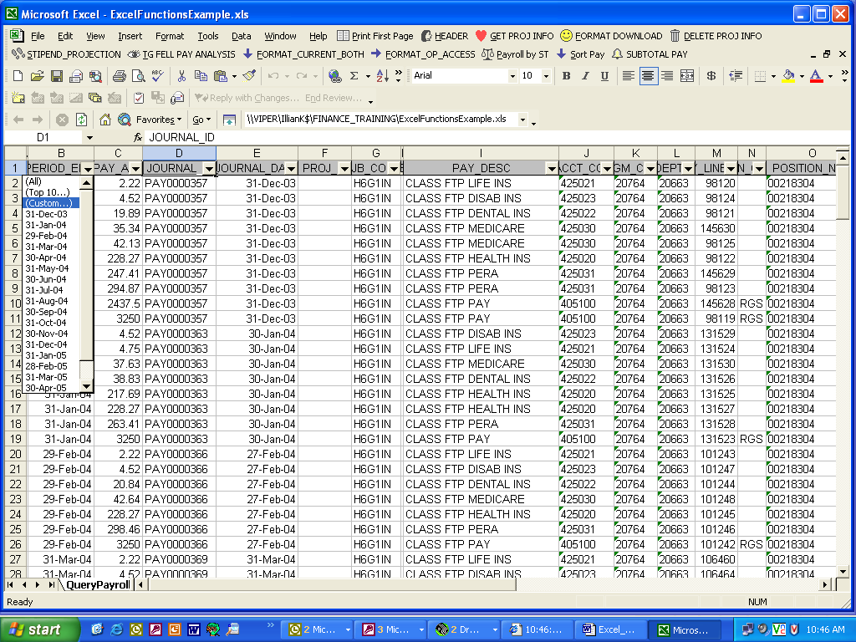

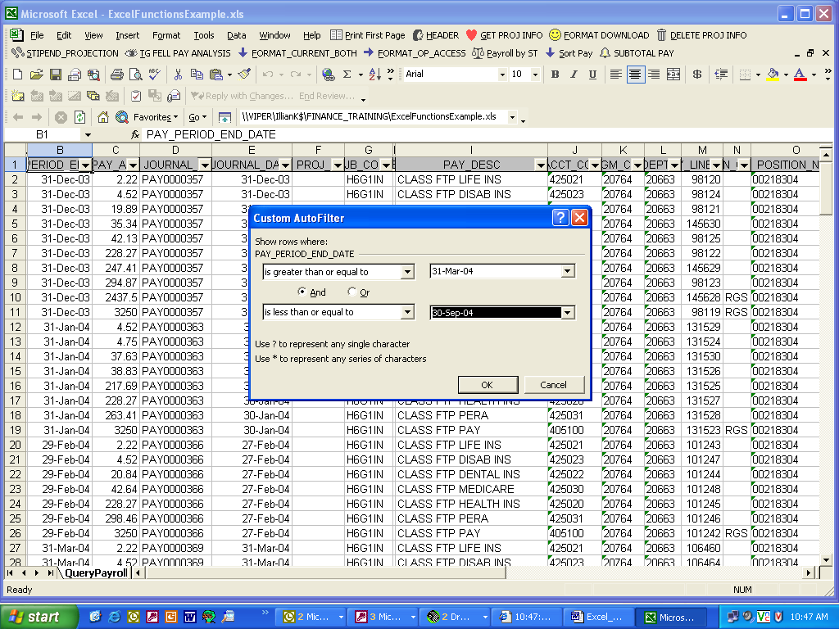

You can sort within a filter too:

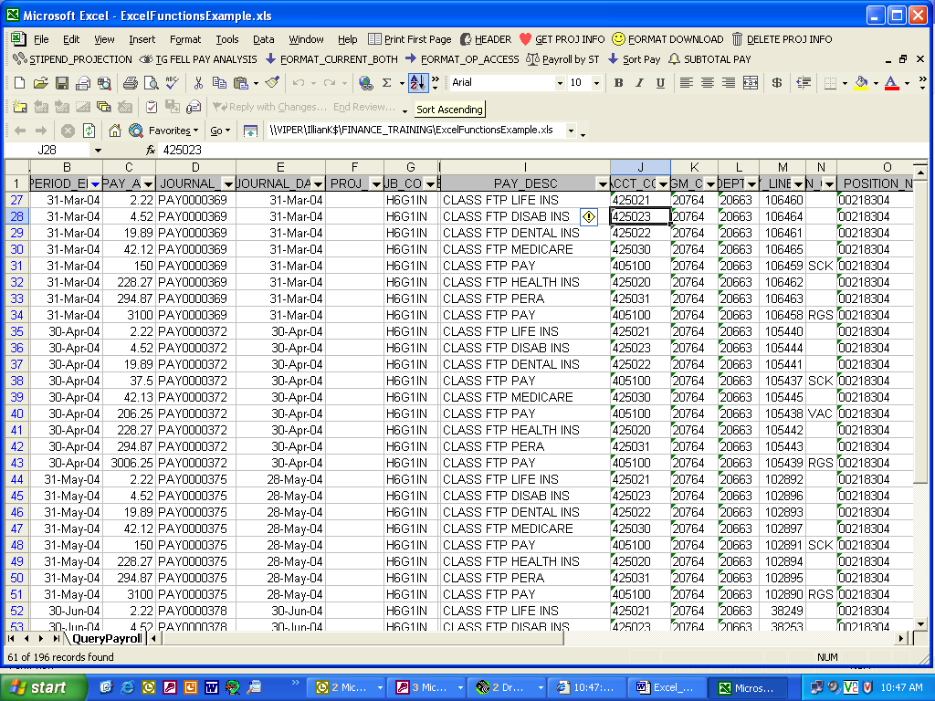

This example is sorted by Account Code:

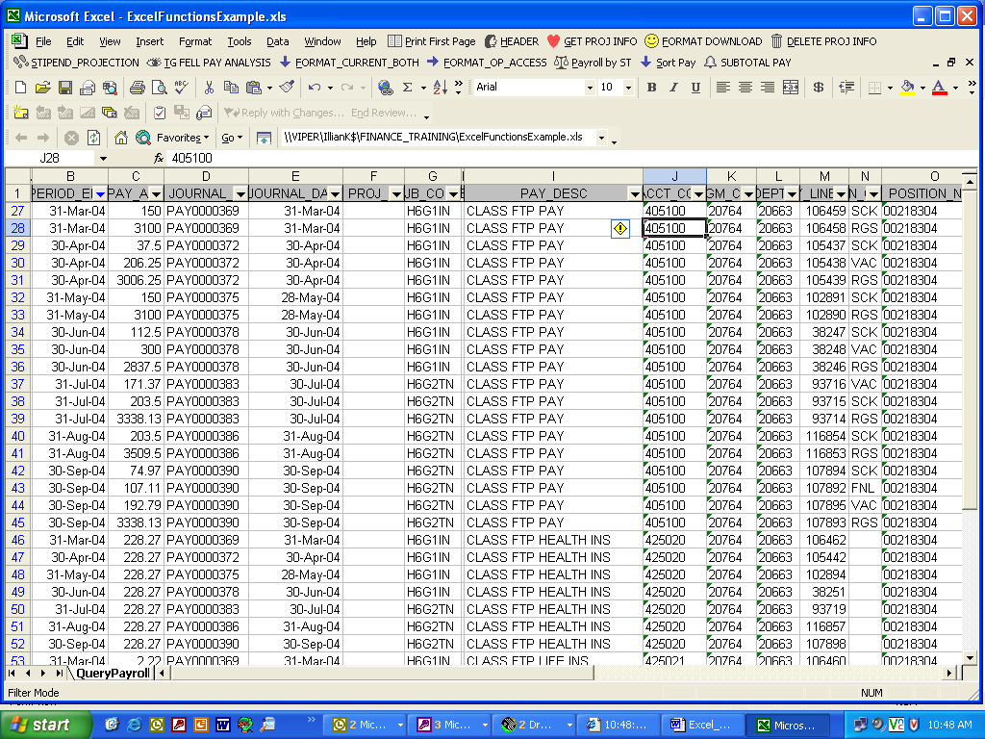

You can do complex sorts too…Data Sort:

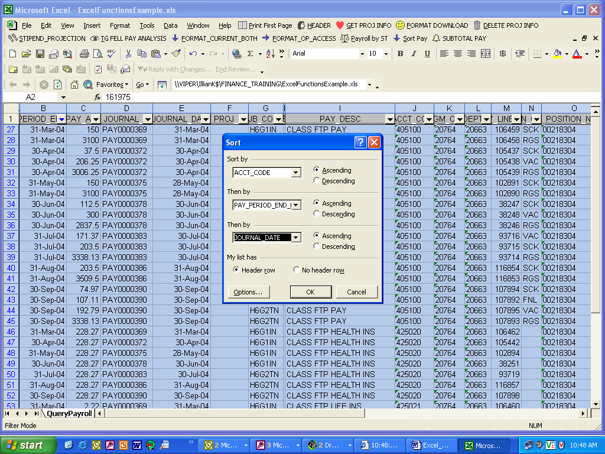

Just click OK if you get this message:

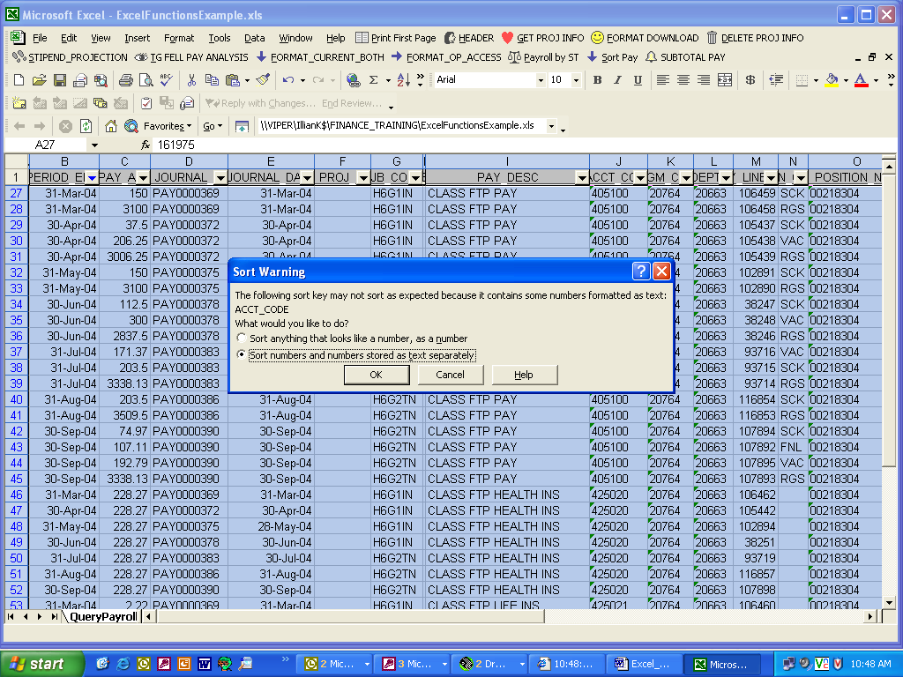

If you get confused about how much you have drilled down, you can “show all”:

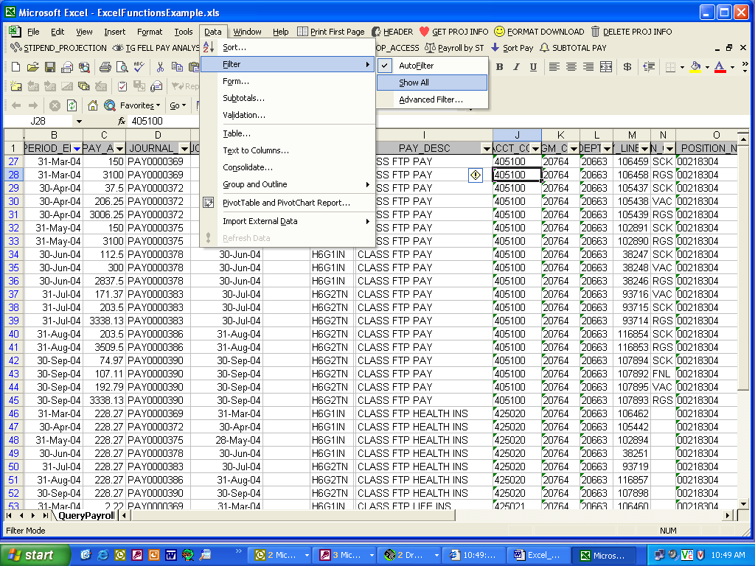

SUBTOTALS:

When you do subtotals, sort the column first:

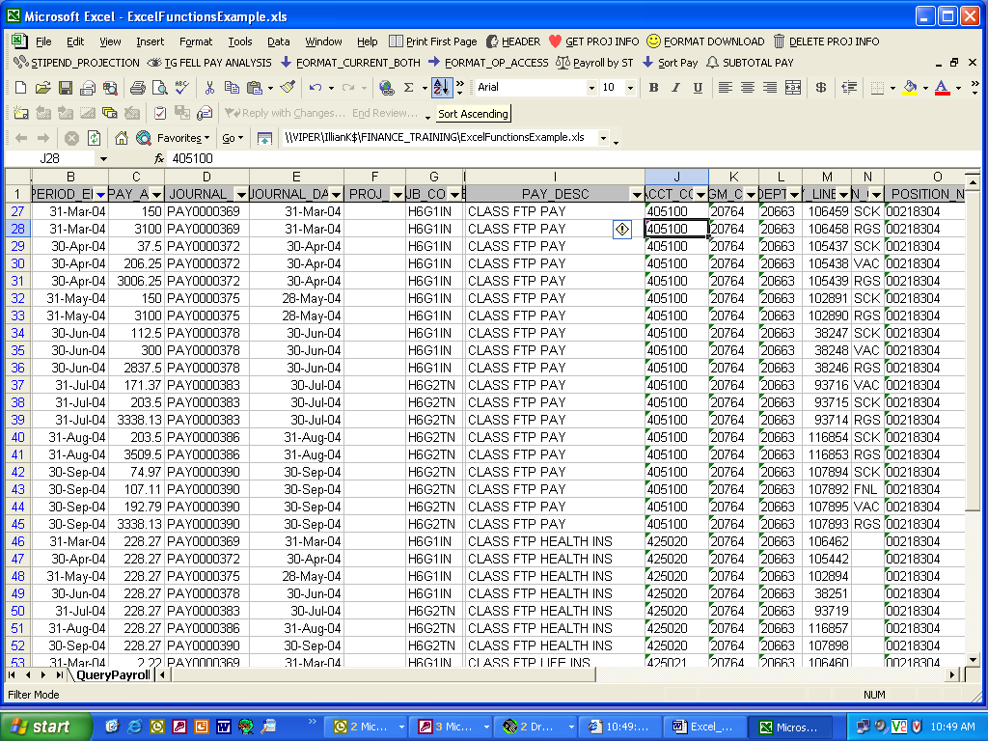

Then do the subtotal: (See next 3 screens):

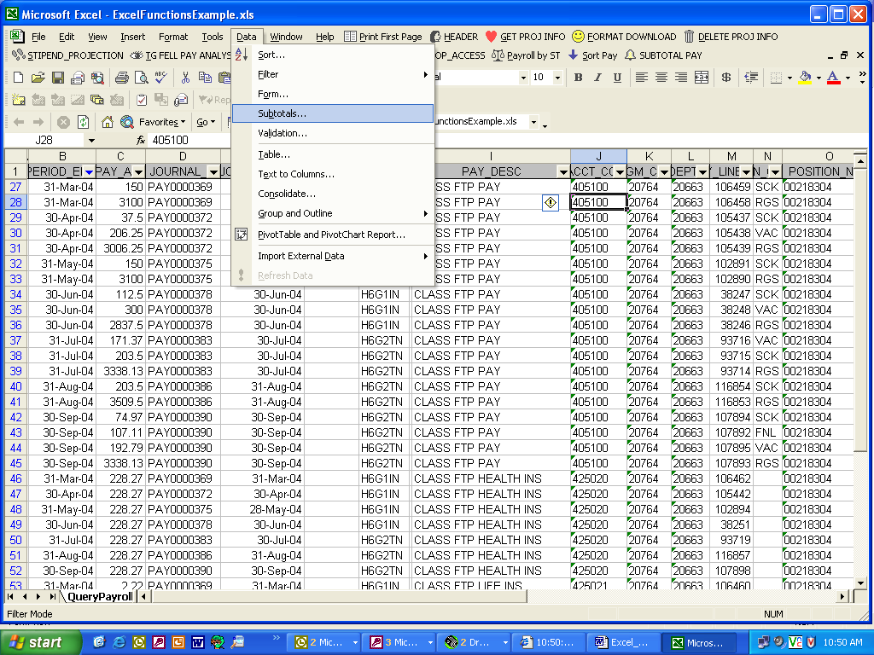

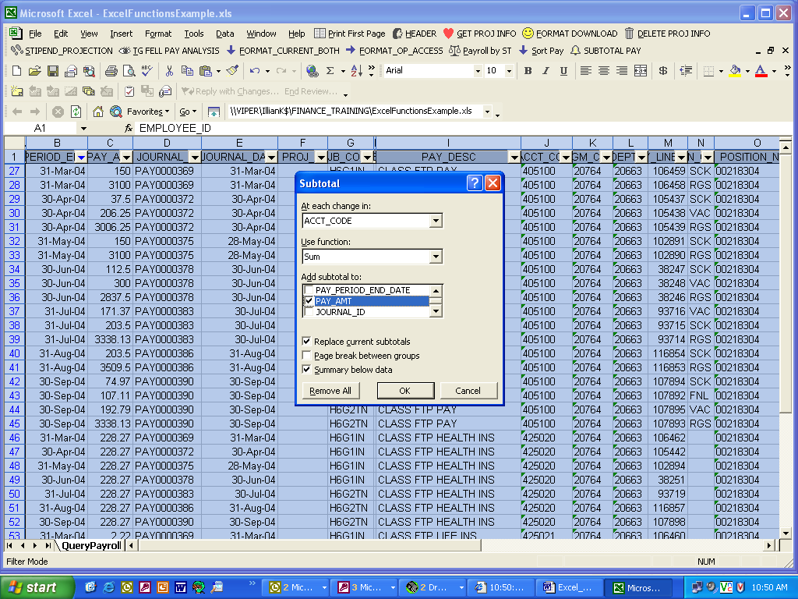

This gives the subtotal of that account code under “Pay Amt”:

